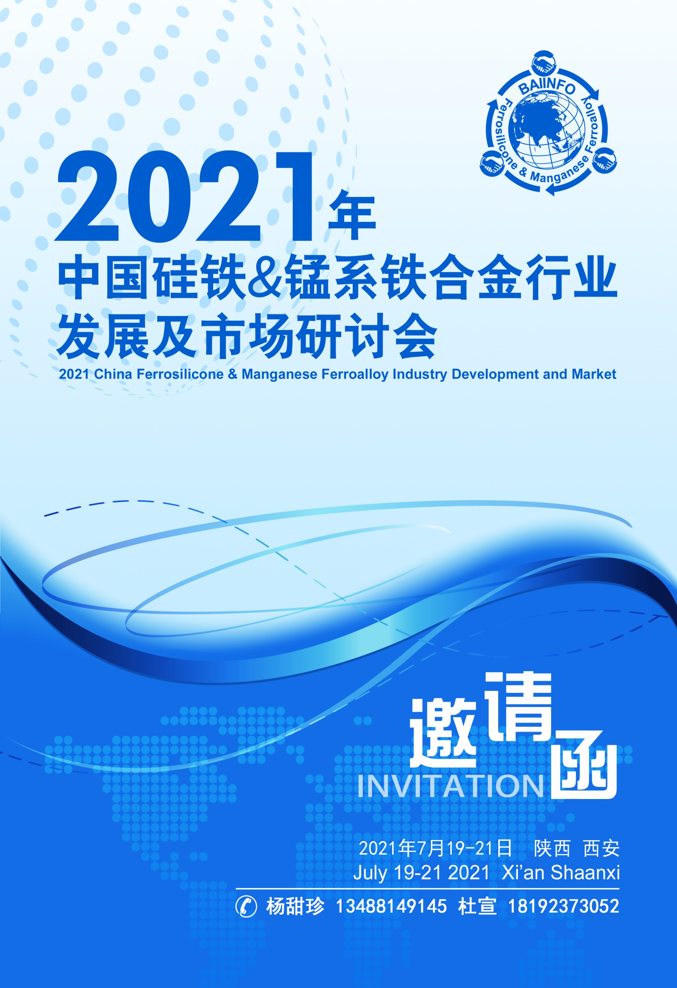
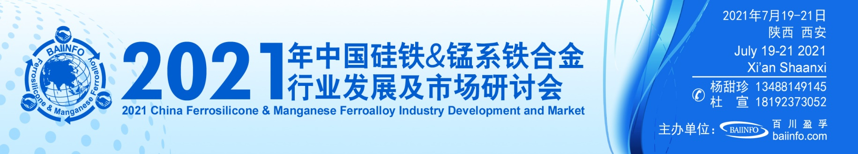
会议背景|Conference Background
2021年，中国疫情影响基本消除，内循环产业强劲复苏，国际疫情影响仍然较大，但随着疫苗接种人数增加，全球经济复苏可期，铁合金行业也迎来一个良好的发展契机。
锰 系：2021年锰系受政策消息影响较大，内蒙古能耗双控、各地区新电价政策侧面影响硅锰市场供应量，从而影响整个市场供求关系。当前，内蒙古耗能限制并未解除，碳排放及控耗等政策将持续存在，当前形势下，锰行业发展变化莫测，未来如何和谐发展，平衡好行业利润与环境之间的关系，是我们需要长期研究的课题。
硅 铁：2021年硅铁受高利润影响，以高开工、高价位开年。在内蒙古能耗双控政策的实施与推动下，硅铁价格维持在高利润水平。对于未来，在能耗双控以及国家限制大宗商品快速上涨的矛盾冲突下，硅价能否持续高位，硅铁未来如何布局，将成为市场最为关注的问题。
百川盈孚拟定于 2021年7月19-21日在中国·西安召开2021年中国硅铁&锰系铁合金行业发展及市场研讨会，研讨现状，前瞻未来，共同助力行业健康发展。

会务联系|Conference Services
姓 名 | 手机（同微信） | 姓 名 | 手机（同微信）
张如风 | 18610320955 | 杜帅兵 | 18522008537
杨甜珍 | 13488149145 | 杜 宣 | 18192373052
宋 缀 | 18161828641 | 董青青 | 13379073539
刘富松 | 13194244662 | 谭 艳 | 18610108590

会议日程| Conference Agenda

日期 | 时间 | 内容
2021年7月19日（周一） | 10:00-20:00 | 会议签到
2021年7月20日（周二） | 08:30-17:00 | 主题演讲
 | 18:00-20:00 | 晚宴联谊
2021年7月21日（周三） | 08:30-17:00 | 商务活动

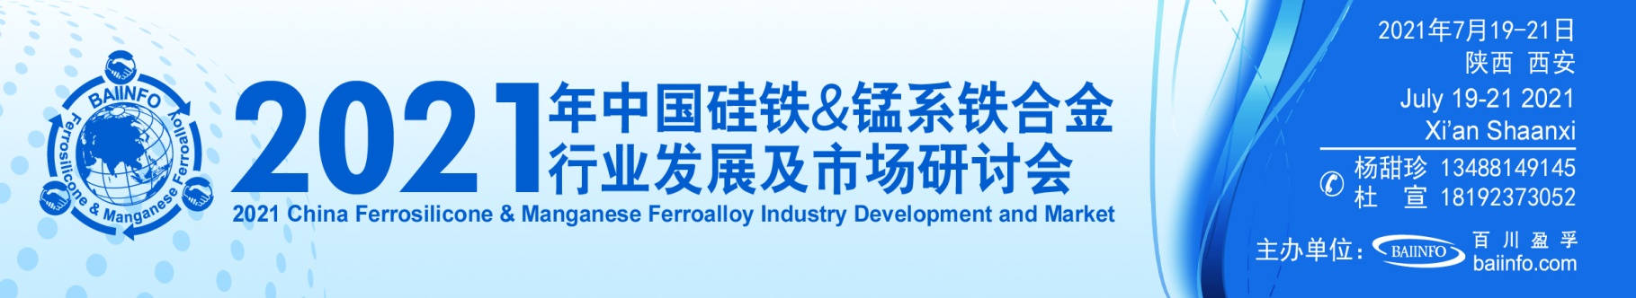
会议议题| Conference Topic
8:30-8:40 | 开幕致辞
8:40-12:00 | 主题演讲
 | 一、 宏观政策
 | 1、2021年全球宏观经济形势分析
 | 2、当前中国宏观经济运行特征及政策走向分析
 | 二、 原料市场分析
 | 1、库存长期高位下，锰矿价格未来走势分析
 | 2、疫情常态下，国外大矿山发运量盘点
 | 3、“双碳”目标下煤炭行业的未来走势
 | 三、 合金生产设备情况
 | 1、新环保形势下矿热炉改造势在必行
 | 四、 期货产品分析
 | 1、钢厂铁合金招标及期货走势的相关性分析
 | 2、硅铁、硅锰期货运行情况及风险管理
12:00-14:00 | 自助午餐
14:00-17:00 | 五、 基础铁合金产品分析
 | 1、硅锰基本面数据分析及行业未来发展趋势
 | 2、硅铁基本面数据分析及行业未来发展趋势
 | 3、电解锰供需数据分析及价格预测
 | 六、 合金与下游市场
 | 1、金属镁行业运行情况、未来发展形势及对硅铁的需求
 | 2、铁合金在铸造行业的应用和发展
 | 3、中国钢铁总体运行情况及未来发展新趋势
 | 4、碳中和、碳达峰下钢材市场形势及对铁合金的影响
18:00-20:00 | 招待晚宴

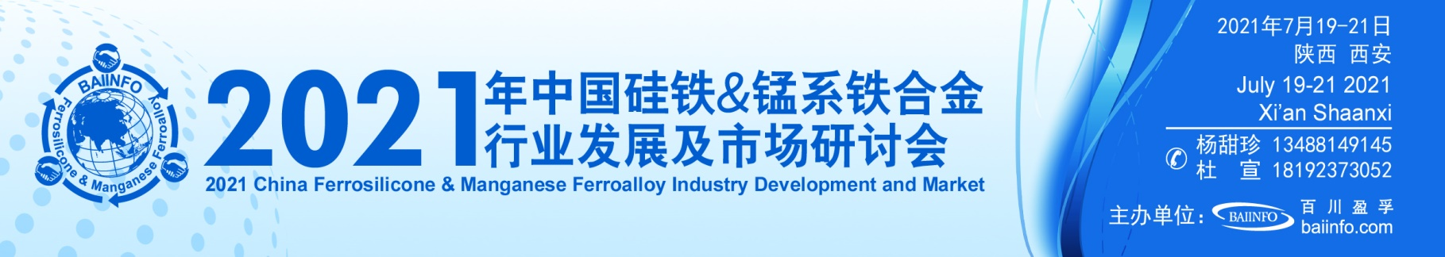
汇款信息
Remittance

公司名称：
北京百川盈孚科技有限公司
开户银行：
招商银行北京静安里支行
银行账号：
1109 3077 0810 101
暨百川盈孚（www.baiinfo.com）

温馨提示：
请参会代表认真填写“参会回执”并盖章后，回传至我公司。
国内客户：
6月20日前汇款 3000元/人
7月10日前汇款 3200元/人
7月10日后汇款 3500元/人
Overseas Delegates: US $ 1000/person
备注：会务费包含会议资料、会议期间自助餐、晚宴、联谊活动费用，不含往返交通及住宿费用。

参会回执| Registration Form
企业名称
（发票名称及签章）
通讯地址 |  |  |  | 邮 编
电子邮箱 |  |  |  | 网 址
参会代表 | 姓 名 | 职 务 | 联系电话 | 手 机 | 传 真
酒店信息 | 大床房 间 |  | 双床房 间
（可选）
入住日期：2021年 7 月 日 离店日期：2021年 7 月 日
温馨提示：酒店房源有限，本次会议协议接受的订房截止日期为7月12日，逾期请客户自主选择住宿。
回执请传真至010-58946899或 百川盈孚：

注1：会务组统一安排食宿，住宿费用自理。
注2：我们将根据“参会回执”、网上报名确认为您安排房间和准备资料。由于房源紧张，7月12日之前没有注明住宿要求的，会务组将不能保证安排住宿，由此带来不便敬请谅解。
注3：参会代表将收到会议各项最新信息，正式日程安排将于2021年7月15日前发出。已交费但因故无法参会者，请以书面形式提前通知会务组，以会议开始日期为准，提前四周通知会务组全额退费，提前两周通知会务组半额退费，其余情况不予退费。以上退费均扣除10%手续费。
注4：此报名表复印有效。
注5：各企业需要开具增值税发票的，请在回传参会回执的同时附上开票信息。

